### **Power Amplifier (PA)**

RF Power Amplifiers are typically used as the final gain stage within the Transmitter chain in a wide variety of applications, such as Wireless Communications. The design of the Power Amplifier is one of the most important in the transceiver architecture, since the linearity of the system is dominated by the last stage. Linearity constraints are solely dependent on whether the waveform is a variable-envelope signal or not, and a quantitative measure of the signal’s envelope variations is the PAPR (Peak-to-Average-Ratio). A signal with high PAPR will have large variations in its amplitude, while one with low PAPR will tend to have a constant envelope. Waveforms that have high PAPR will consequently need more power backoff from the power amplifier’s P1dB compression point. The P1dB compression point is where the gain of the device drops by 1dB with an increase in input power by 1dB. Any further increase in input power will operate the device in the nonlinear region, which clips the signal amplitude in the time domain and therefore creates distortion. For waveforms with high PAPR, such as SSB (single sideband), a very linear power amplifier must be used since the desired message has been modulated onto the carrier’s amplitude. Using a nonlinear amplifier will distort the transmitted signal, therefore distorting the message to be received.

Our Linear Transponder will receive either CW (continuous wave) or SSB (single sideband) signals; moreover, the design of the PA will dictate whether the message encoded on the transmitted signal will be successfully received on Earth’s ground station. When determining a proper PA for our application, the following must be taken into consideration: linearity, efficiency, gain, power consumption, output power compression point, temperature rating, rated frequency range, and signal modulation type.

Considering the aforementioned criteria, the following power amplifiers were selected as potential candidates:

|  |  |  |  |  |  |  |  |  |  |  |
| --- | --- | --- | --- | --- | --- | --- | --- | --- | --- | --- |
| Power Amplifier | Mfr. | Frequency Range | Gain | OP1dB | Linearity | ŋ | Supply Voltage | Supply Current | Power | Operating  Temp. |
| **Ideal** | **N/A** | **29 MHz** | **30 dB** | **>21 dBm** | **High** | **Class-A,AB,B** | **5-8V** | **< 300 mA** | **<1.5W** | **-40 to 85 ℃** |
| [SXB2089Z](https://drive.google.com/drive/u/0/folders/1_lY_uIQ3X1faWF13e4d7qJUT5A20ar9M) | RFMD | 5MHz - 2500MHz | 25dB | 24 dBm | High | N/A | 8V | 135 mA | 1.08W | -40 to 85 ℃ |
| [CGR-0118Z(CATV)](https://drive.google.com/drive/u/0/folders/1_lY_uIQ3X1faWF13e4d7qJUT5A20ar9M) | RFMD | 5 MHZ -65 MHz | 25.4 dB | 26.5 dBm | N/A | N/A | 8V | 130 mA | 1.04 W | -40 to 150℃ |
| [RF3827](https://drive.google.com/drive/u/0/folders/1_lY_uIQ3X1faWF13e4d7qJUT5A20ar9M) | RFMD | 5 Mhz - 1500 MHz | ≅19 dB | 23 dBm | High | N/A | 8V | 100 mA | 800 mW | -40 to 85℃ |
| [TQP3M9019](https://drive.google.com/drive/u/0/folders/1_lY_uIQ3X1faWF13e4d7qJUT5A20ar9M) | Qorvo | 20-4000MHz | 22 dB | 22 dBm | High | N/A | 5V | 125 mA | 625 mW | -65 to 150℃ |
| [AFIC901N](https://drive.google.com/drive/u/0/folders/1_lY_uIQ3X1faWF13e4d7qJUT5A20ar9M) | F.S | 1.8 - 1000MHz | 30 dB | 30.6 dBm | N/A | 62.1% | 7.5V | IDQ1 = 8mA  IDQ2= 24mA |  | -65 to 150℃ |

**Table (xxx):** Power Amplifier Candidates

Although each PA meets our basic requirements, there is one major problem is present among all of them: efficiency. Due to their Class-A topology, each of these PA’s will have a constant output current flow, meaning it will conduct for the full cycle of the input signal. This allows the output signal from the PA to very closely follow the input signal to the PA, which classifies it as highly linear. However, due to it always conducting, it has only 50% efficiency.

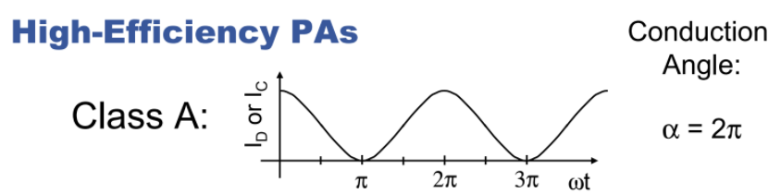

**Figure (xxx):** Class-A PA (cite this)

This is a highly undesirable characteristic for our transponder design, and instead a Class-B Push-Pull PA will be designed and implemented. These PA’s offer higher efficiency, since the transistor only conducts for half of the time, thus the conduction angle is approximately 180°:

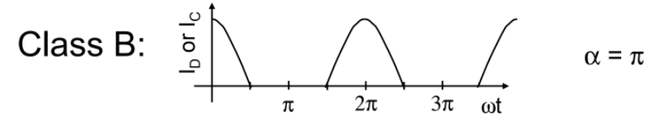

**Figure (xxx):** Class-B PA (cite this)

However, since only half of the input signal will be present at the output, there will be significant distortion. To compensate for this distortion, the output signal of the PA will be fed back into the input of, for example, an operational amplifier (the actual topology of this block has not been determined yet) which will be compared to the input signal. The difference between the two will then be the input into the PA; this feedback topology will be the key ingredient in increasing our linearity, while still maintaining higher efficiency than Class-A Amplifiers.

**For the Class-B design and implementation, please refer to Linear Transponder → Design → PA → Documentation**